1.Look at the pictures and write

   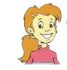

Lisa

Amy

John

Tony

Peter

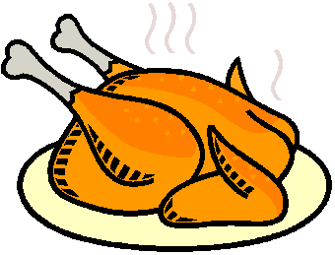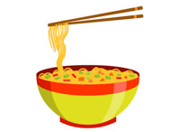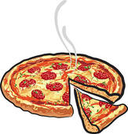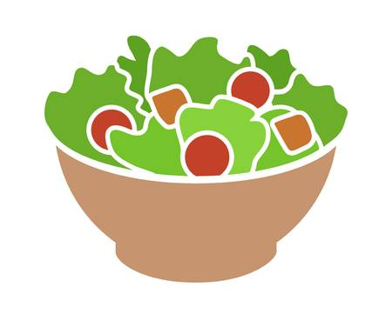

a. Peter has noodles.

b. Tony________________________________________.

c. John ________________________________________.

d. Amy ________________________________________.

e. Lisa ________________________________________.

2.Complete with **have** or **has**

a. I ________ chicken. b. She _________ an apple.

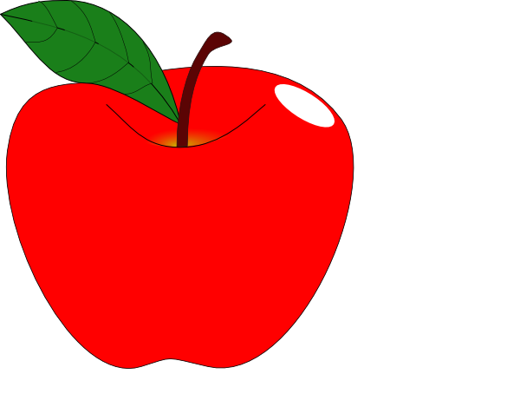

c. She _________ a pizza. d. He __________ a milkshake.



e.I ________ a sandwich. f. They ____________ grapes.

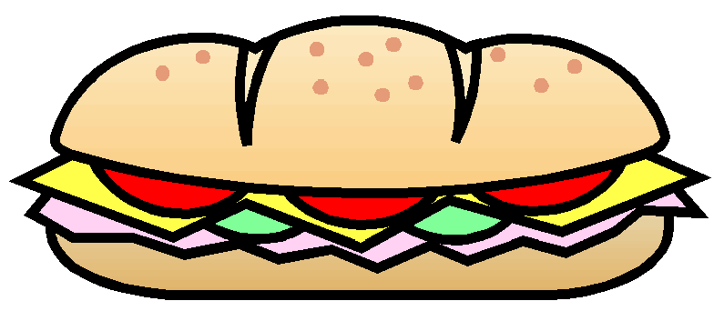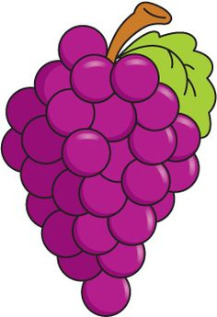

g. Lisa _______ salad . h. Lisa ________ a banana.



3 .Reorder the words to make the correct sentences.

a. Does /have /she / a /banana ?/ __________________________________.?

b. have /Do /apple ? /you /an /_____________________________________?

c. She / has / fries./ __________________________________.

d. chicken./Mary / has / _____________________________.

e. /an /orange./ He /has /__________________________________.

f. have /We/ a /pizza./ _________________________________.

g. They /have / sweets./ _______________________________.

h. Does/ have/ she / salad ?/ __________________________________?

i. Lily / an /orange./ has / ______________________________.

j. they/ Do/ have/ biscuits?/ ____________________________________?

4.Complete the sentences.

|  |  |  |
| --- | --- | --- |
|  | 1.They **have**  some milk but they **don’t have** any yogurt.  2.They _________a banana but they __________an orange.  3.They _____________ a hamburger but they________ noodles.  4.They _________ any juice but they ________some fries. |  |
|  | 1.He **has** some juice but he  **doesn’t have** any chips .  2.He __________a sandwich but he __________ chicken..  3.He _________any milk but he ___________some yogurt.  4.He _________a banana but he _________an orange. |  |

5. Fill in the blanks.

a. Do you have an apple ? Yes , I ___________________.

b. Does she have a banana ? No , _________________.

c. Do they have fries ? Yes , _____________________.

d. What do you have ? I ______________ a pizza.

e. What does she have ? She ____________ chicken.

f. Does she have a sandwich ? Yes , she ___________.

g. Does he have grapes ? Yes , _________ does.

h. What does he have ? He ______________ an apple.

i. ___________ she have chicken ? Yes , she does.

j. What _________ she have ? She has salad.

k. Does Lily have a pizza ? ____________ , she does.

l. Does Peter have noodles ? No , he __________.